**DAILY ONLINE ACTIVITIES SUMMARY**

|  |  |  |  |  |  |  |  |  |
| --- | --- | --- | --- | --- | --- | --- | --- | --- |
| **Date:** | **01/06/2020** | | | | | **Name:** | **VIRESH** | |
| **Sem & Sec** | **4th SEM & ‘B’ SEC.** | | | | | **USN:** | **4AL18CS097** | |
| **Online Test Summary** | | | | | | | | |
| **Subject** | | **Complex analysis, Probability and Statistical Methods** | | | | | | |
| **Max. Marks** | | **30** | | **Score** | | | **29** | |
| **Certification Course Summary** | | | | | | | | |
| **Course** | **Cloud Foundations** | | | | | | | |
| **Certificate Provider** | | | **Greatlearning Academy** | | **Duration** | | | **4.5 Hrs.** |
| **Coding Challenges** | | | | | | | | |
| **Problem Statement 1:** Given an array arr[] of size N and an integer K. The task is to find  the count of subarrays such that each subarray has exactly K distinct elements.  **Problem Statement 2:** Given an array of positive integers. Write a C Program to find the leaders in the array. | | | | | | | | |
| **Status: Done** | | | | | | | | |
| **Uploaded the report in Github** | | | | | **Yes** | | | |
| **If yes Repository name** | | | | | **Lockdown-Coding**  <https://github.com/viresh-kulal/Lockdown-Coding> | | | |
| **Uploaded the report in slack** | | | | | **Yes** | | | |

**Online Test Summary: Today 18MAT41 test was scheduled from 9:30am to 10:10am .The portion for the IA was 5th module, there were 30 questions and the time assigned was 40 minutes the questions were MCQ type.**

**This is the snap shot of completion of the test and marks obtained in 18MAT41.**

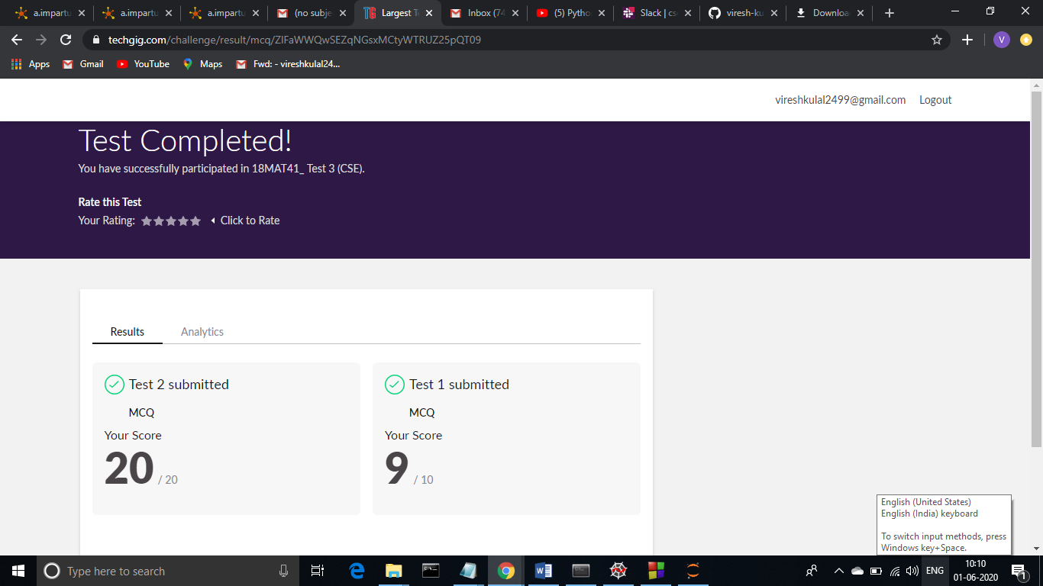

**Online Certification Course Summary: In today’s session I have learnt about Cloud Attributes, Managed Services and Deployment Models. And also came to know about Pricing and Scaling Models in Cloud Foundations.**

**The snapshots of today’s session is attached below.**

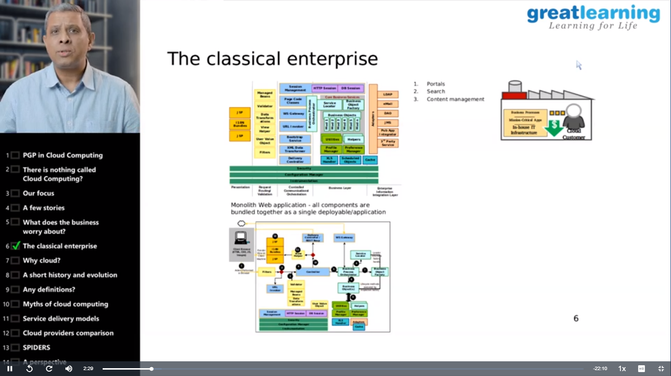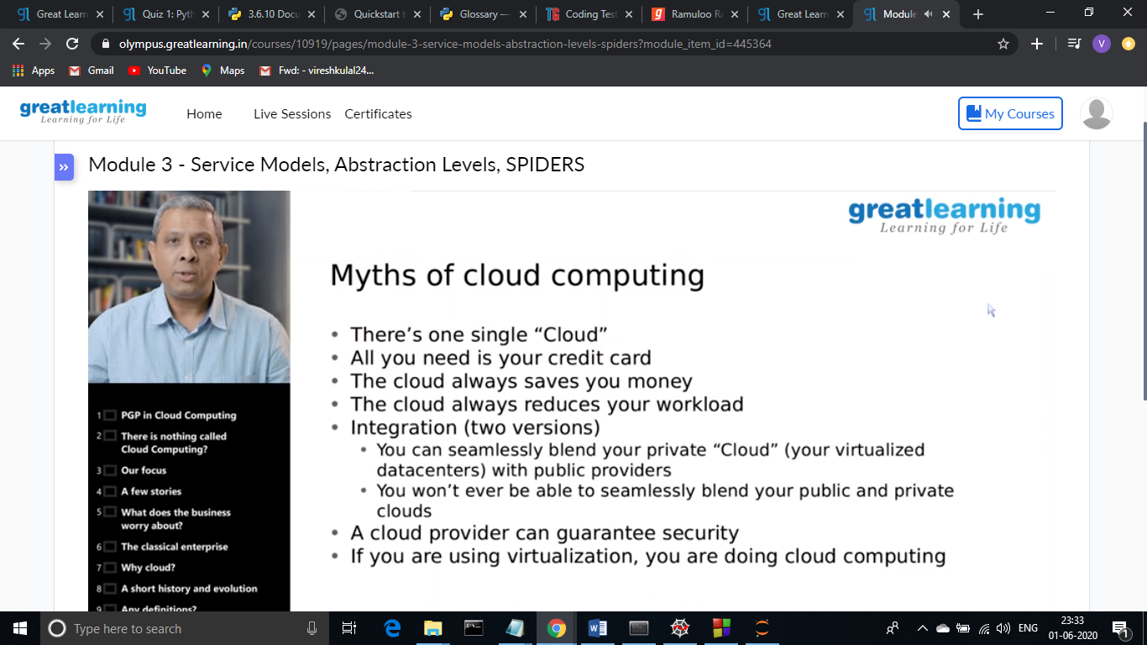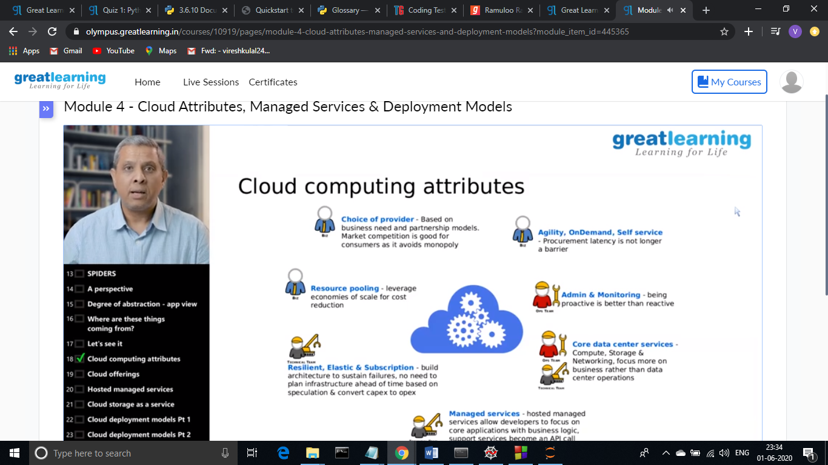

**Online Coding Summary: Today I had received one program from prof. Vasudev CSE Dept. and another from prof. Venkatesh CSE Dept. The programs is mentioned above (pg.01). I have also uploaded it to my Github repository.**

The Repository link is: <https://github.com/viresh-kulal/Lockdown-Coding>

**It is the snap shot of my repository were I have uploaded the code. File name is distinct.cpp and leaders in array.c**

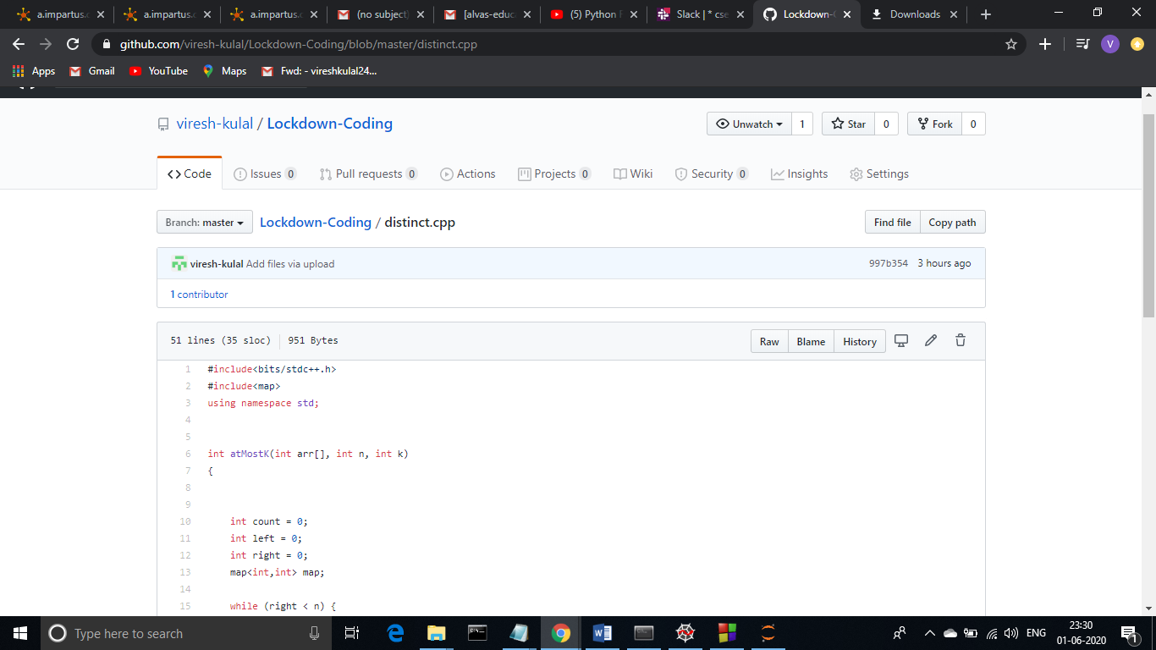

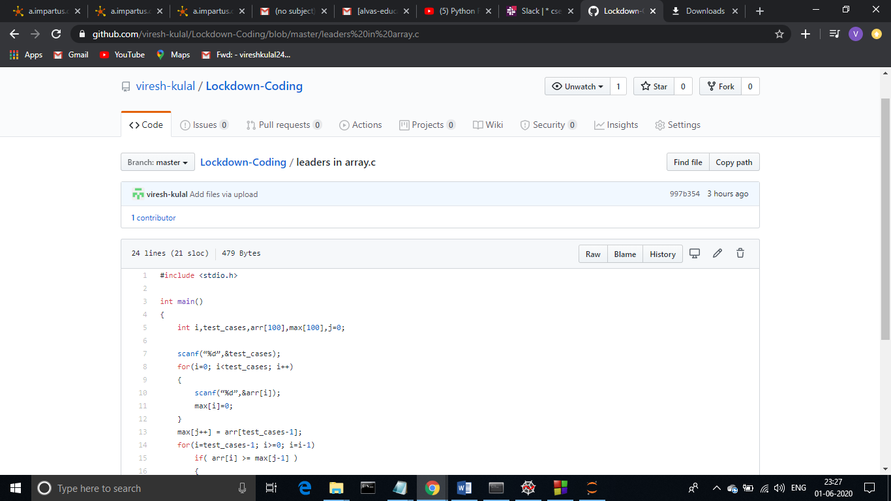

**Thank you.**